In class activity: Fixing bad charts
We are going to tie together what we’ve learned so far about making effective and expressive charts, considering perception and Gestalt principles, and appropriately answering a question with a chart.
You will choose 1 chart to work with. You’ll answer the questions below about your one chart, and end with a sketch of a redesign. This is similar to what we did on Monday, but on Monday we focused on asking our own questions about a dataset. Here, the question being asked it set for us, and we want to improve the way it gets mapped to a chart and fix any errors the designer may have made in the process.
Step 1. Reimagine what the data looked like originally. Below, sketch out a possible data table with attributes as columns and data items as rows. If your chart contained a derived attribute, you might imagine what the original dataset looked like, or you can consider the derived attribute to be one column. If your chart groups information, think about what the original data items (separate observations) would have looked like.

Step 2. Identify the goal of the chart you have, then write a specific and clear question the overall chart is answering. Then identify the task associated with such a question using the taxonomy from last class’s slides. There may be more than one question/task.
GOAL OF DESIGNER: Exploratory or explanatory? Was the purpose to record information, develop and assess hypotheses, find patterns, discover errors or outliers, gain intuition, persuade others, communicate information? Why?

Step 2, cont. OVERALL QUESTIONS/TASKS: What did the designer ask about the dataset to get to this chart? What task(s) is(are) associated with the question(s)?

YOUR QUESTION: Based on the data, is there a specific question/task the designer didn’t emphasize, but you would for your redesign? This will be your primary task going forward. Alternatively, if you identified multiple questions above, pick one primary task that you think is most important.

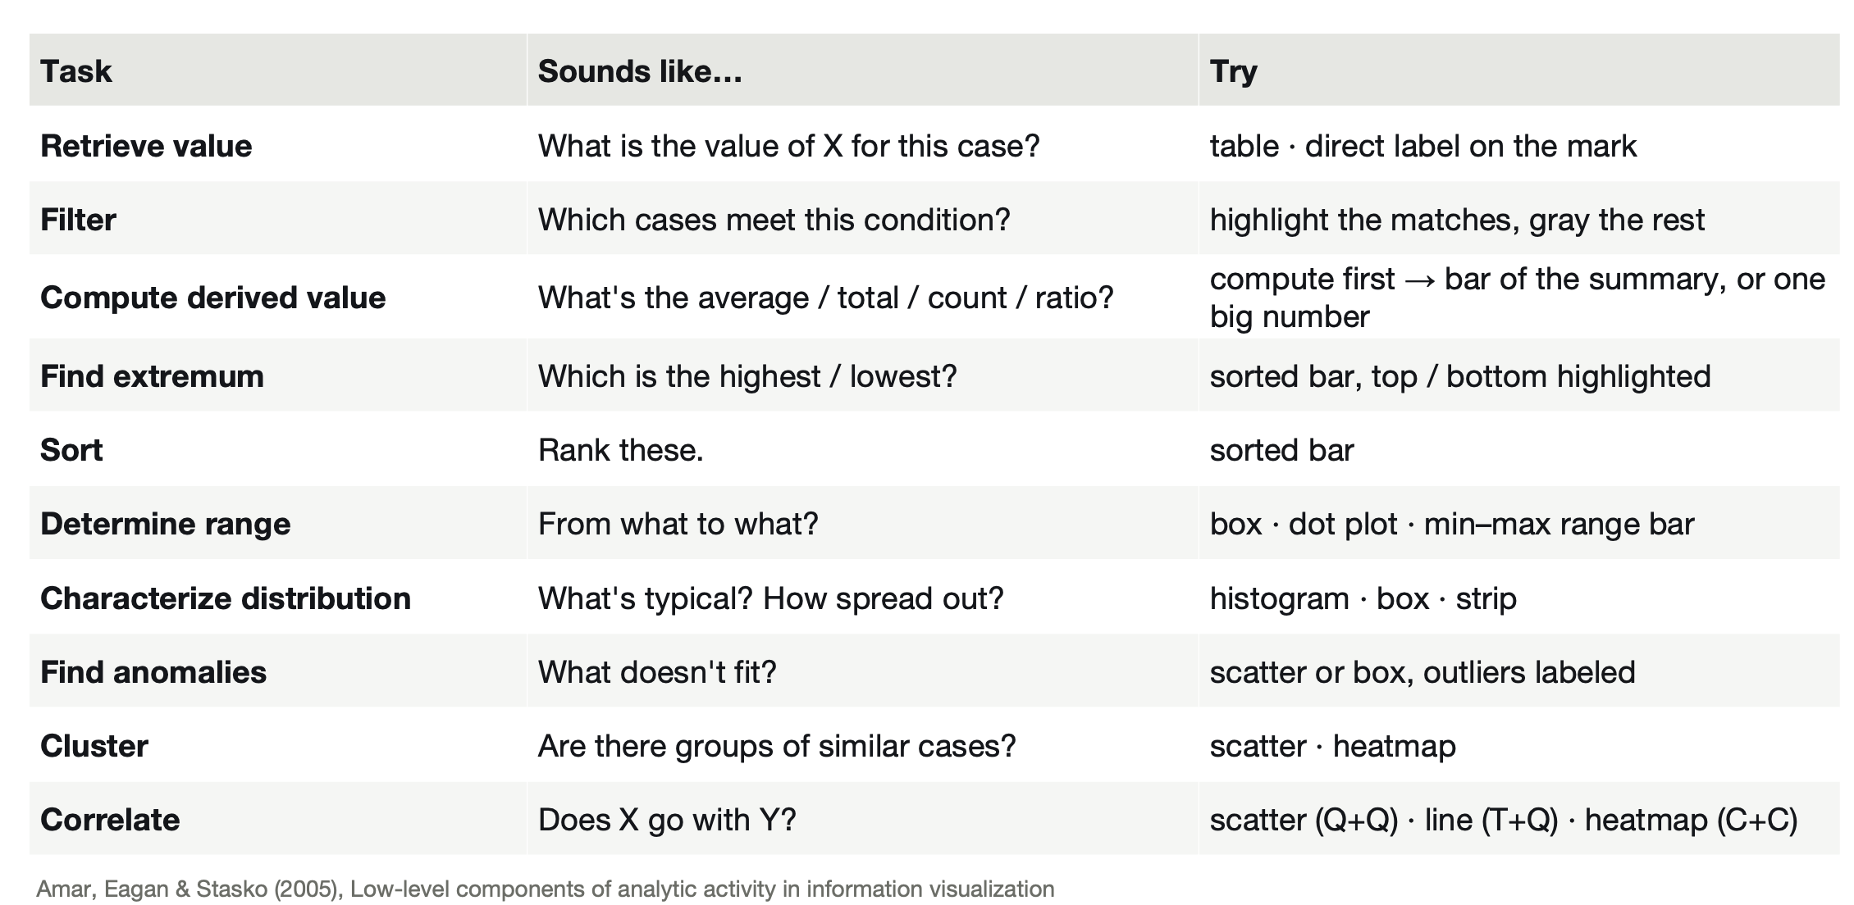

Step 3. Identify the relevant attribute types, channel mappings, and what a single data mark is.
Data item: Type of mark:

Attribute mappings [attribute (NOIR) channel]

Step 4: You may want to consider a different chart type than what the design used. Consider the question being asked, the associated task, and the attribute types you have. With all of this information, determine whether the chart type is appropriate. If not, pick a new chart type (or list a few options) for the redesign. Write the specifics of how each attribute could be encoded in the redesign (i.e. any updated attribute mappings or item mark mappings).

Step 5: Using what you know about effective encodings, expressiveness, and perception, write what needs to be improved. Thoughtfully reflect on each box below. If it truly doesn’t apply, write NA.
Effectiveness channel rankings
Accuracy/lie factor/Expressiveness
Scale choices (start at 0, log vs linear, scale breaks)
Aspect ratio
Domain to range mapping
Use of color
Weber’s law
Steven’s power law
Discriminability
Separability

Step 6: Consider the overall task and goal of the chart once again. Are there ways to use pop out, grouping, and/or Gestalt principles to ensure that the purpose of the chart is obvious, even if you aren’t there to explain it to someone? Thoughtfully reflect on each box below. If it truly doesn’t apply, write NA.
Proximity
Similarity
Symmetry
Connectedness
Continuity
Closure
Common fate
Popout

Step 7: Collecting all the choices you’ve made above, sketch out your chart redesign. Make sure to include important chart anatomy, like a title, axis ticks and labels, and a legend if appropriate. You can make several sketches if you can’t decide on one idea but pick your favorite as the redesign you propose.

Step 8: Critique with other groups.
- First, share your redesign with another group that had the same original chart as you. Don’t explain your redesign; let the chart speak for itself. Record their suggestions here: what worked? What didn’t? What could be improved?

- Next, share your redesign with another group that had a different original chart from you. Don’t explain your redesign; let the chart speak for itself. Record their suggestions here: what worked? What didn’t? What could be improved?

